Rational Numbers on a number line
We know how to represent integers on a number line. Let us draw one such number line.
The points to the right of 0 are denoted by + sign and are positive integers. The points to the left of 0 are denoted by – sign and are negative integers.
We can also represent the rational numbers on the number line. Let we want to represent -1/2 on the number line. The rational number -1/2 lies between 0 and -1. So, -1/2 - would be marked at a point half the distance between 0 and –1 and we can represent this number as shown in the figure.
In the same way, we can represent other rational numbers also on the number line.
Problem: Draw the number line and represent the following rational numbers on it:
(i) 3/4 (ii) -5/8 (iii) -7/4 (iv) 7/8
Solution:
(i) Given rational number is 3/4
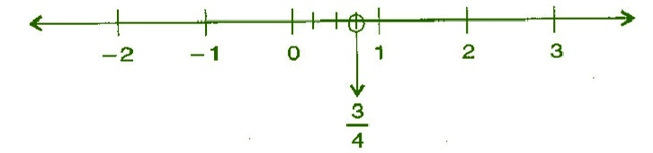
(ii) Given rational number is -5/8
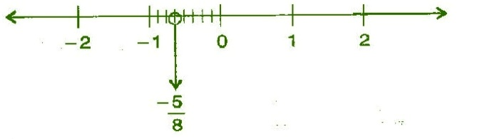

(iii) Given rational number is -7/4
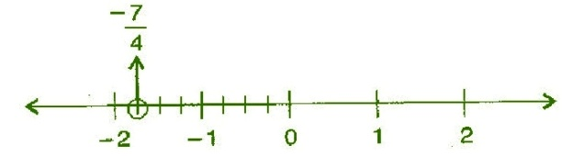

(iv) Given rational number is 7/8
